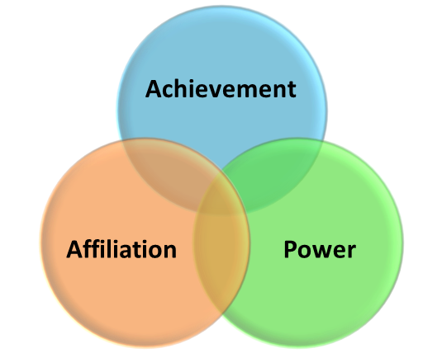**McClelland’s Theory of needs**

The acquired-needs theory was developed by David McClelland, and is called "***McCelland's*** " (sometimes as the "Three Need Theory" or the ""). McClelland proposed that ***an individual's specific needs are and are*** . According to McClelland, most of human needs and/or motives can be classified as . He found that a person's motivation and effectiveness in certain job functions are influenced by these three needs. Thus, the importance of a particular need depends upon the position.

***The need for (N-Ach) is*** . People with a high need for :

* *Desire that is related to their performance on tasks*
* *Seek to and thus tend to avoid both*
* *Like to*

*Predominantly achievement-motivated individuals*  because they find easily attained success is not genuine achievement; rather they attribute it to the ease of the task not their own effort. Similarly, *they*  , regarding success as the result of chance not their competence. Thus*, individuals with high need for achievement are* . Rather,. McClelland suggested that *people with high achievement need* , although they tend to expect those that they work with also to be result driven and may expect too much from them. Their aggressive realism makes them successful entrepreneurs.

***The need for (N-Affil) is the desire for*** . People with high need for :

* Want to be liked and feel accepted by other people
* Tend to conform to the norms of their work group
* Prefer cooperation over competition
* Enjoy being part of a group.

High affiliation need individuals *prefer work that provides significant , and depends on* , such as customer service. They are *concerned with*

. McClelland regarded a strong need for affiliation as undermining the objectivity and decision-making ability needed in management.

***The need for (N-Pow) is a desire for , to be . It takes two forms— and*** .

* Those who desire personal power *want to* ; this need often is perceived as undesirable
* Those who desire institutional power (also known as social power) *want to to further larger goals*, such as those of an organization

In management, while the job requires directing others, those with a high need for personal power may become dysfunctional as their focus is on the directing of others rather than on the achievement of the company's goals. Managers with a high need for institutional power tend to be more effective than those with a high need for personal power, since they channel their need into accomplishing goals set by the organization. Those whom they direct are more likely to respond positively when they are being directed toward the larger goal.

***McClelland noted that people generally have ; one need, however, tends to be .*** This depends both on their internal make-up, their personality, and also is learned through experience. Unlike Abraham Maslow who developed a hierarchy of needs, McClelland did not discuss these three needs as stages or with transitions among them.

In his later work, McClelland (1988) added a fourth need,  which *functions to motivate people to avoid situations and people with which they have, or expect to have, unpleasant experiences*. These avoidance motives include fear of rejection, fear of failure, fear of success, and generalized anxiety. In this work he also stressed that there are both conscious and unconscious intents that affect a person's motivation.