PY40S Name:

Unit 2

**Maslow’s Hierarchy of Needs**

1. 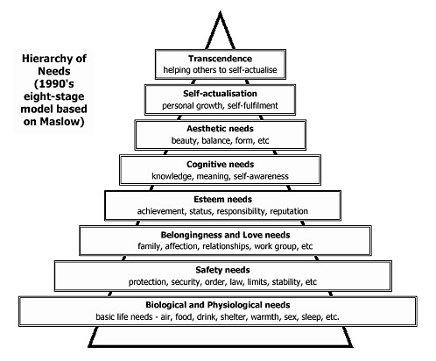According to Maslow’s hierarchy, identify which needs are likely being met in each of the following situations. More than one need may be met in each case.
2. a group of friends go to McDonald’s for lunch

1. a teenager goes to an amusement park with friends

1. a soldier attacks an enemy under fire

1. a child runs home after a fight with a bully

1. a millionaire leaves everything to charity

1. a dentist provides free care to children living in poverty in a low-income area

1. a successful businesswoman enters politics at a salary lower than her previous earnings

1. a student volunteers at a food bank for several hours a week

1. a student spends every spare moment studying for exams

1. a girl asks a friend to go for a walk with her

1. a young lady ran when she saw the man approach her

1. a group of students decides to go bungee jumping

1. a mother spends her evenings reading stories with her children

1. a couple who just moved to a new city sign up for yoga classes at the local community centre

1. a group of students spend their summer building a school in Haiti

1. a) Make a list of the things you would like to accomplish before you are 20, 30 and 40 years of age. For each category, note why you want to accomplish these goals. Categorize each of these goals according to Maslow’s hierarchy.

|  |  |  |  |
| --- | --- | --- | --- |
| **Before** | **Accomplishments** | **Reason?** | **Maslow’s Hierarchy** |
| Age 20 |  |  |  |
|  |  |  |
|  |  |  |
|  |  |  |
| Age 30 |  |  |  |
|  |  |  |
|  |  |  |
|  |  |  |
| Age 40 |  |  |  |
|  |  |  |
|  |  |  |
|  |  |  |