PY40S

**Maslow’s Hierarchy of Needs**

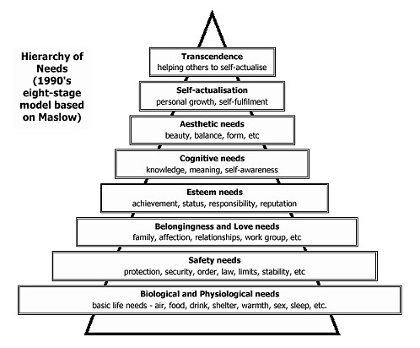

**Give examples of what may fulfill a need in your life (or someone your age) for each section of the pyramid.**

1. Biological and Physiological Needs:
2. Safety Needs:
3. Belongingness and Love Needs:
4. Esteem Needs:
5. Cognitive Needs:
6. Aesthetic Needs:
7. Self-Actualization:
8. Transcedence: