PY40S Name:

Unit 2

**Functions of the Brain**

1. **Cerebrum: 2 halves**

|  |  |
| --- | --- |
| ***Right*** |  |
| ***Left*** |  |

1. **Cerebral Cortex: 4 lobes**

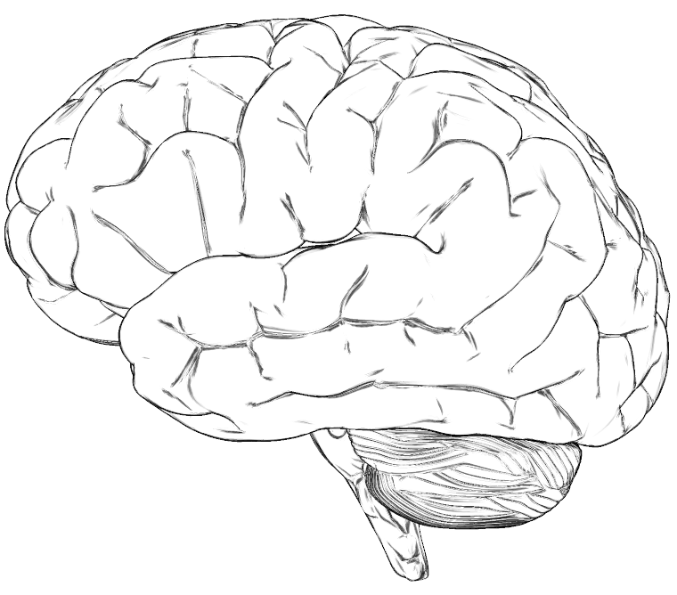

|  |  |
| --- | --- |
| **Lobe** | **Responsibilities** |
|  |  |
|  |  |
|  |  |
|  |  |

1. **Functions and Impairments**

|  |  |  |
| --- | --- | --- |
| **Part of the Brain** | **Functions** | **Symptoms of Impairment** |
| ***Frontal Lobe*** |  |  |
| ***Occipital Lobe*** |  |  |
| ***Parietal Lobe*** |  |  |
| ***Temporal Lobe*** |  |  |
| ***Cerebellum*** |  |  |
| ***Brain Stem*** |  |  |