## Name:

**K** EY

**T** ERMS

These are key terms from this week’s rap. Each word or phrase connects to the week’s news in a

significant way. Complete the chart below by desrcibing how each term relates to the news.

|  |  |
| --- | --- |
| **Term** | **How it Relates to the Week’s News** |
| dress | *Example: This week a picture of a dress went viral.*  Answer: |
| Boris Nemtsov | Answer: |
| IQs | Answer: |
| diversity | Answer: |
| glass ceiling | Answer: |
| Netanyahu | Answer: |
| public utility | Answer: |
| Russia | Answer: |
| Tikrit | Answer: |

**page** • 1

**GENERAL**VOCABULARY

Some words from the lyrics are used to describe a specific news story, but you can also use them in lots of other places and contexts. Learning these words and their meanings will help you expand your vocabulary.

Guess what the meaning of the word is based on how it’s used in the rap, and then compare it with the actual definition. When you’re done, use each of the words in a sentence that doesn’t have anything to do with The Week in Rap.

|  |  |  |  |
| --- | --- | --- | --- |
| **Word** | **In Lyrics** | **Guess Meaning** | **Actual Meaning** |
| ***assassinated*** | *Was he* ***assassinated*** *by those he opposed?* | Answer: | Answer: |
| ***opposed*** | *Was he assassinated by those he* ***opposed****?* | Answer: | Answer: |
| ***halt*** | *Obama wants Iran to halt their program for 10 years* | Answer: | Answer: |
| ***diversity*** | *Diversity’s the next issue they’re gonna tackle* | Answer: | Answer: |

# Word

Answer:

***assassinated***

Answer:

### opposed

Answer:

***halt***

Answer:

***diversity***



**Q**&**A**

THE **WEEK** IN **RAP** 3.6.2015

Read the info boxes from this week’s Week in Rap and answer the questions. To read more about

each story, follow the link to the newspaper article in the info box on flocabulary.com.

The Federal Communications Commission, or FCC, oversees things like television and radio broadcasts. Now, they voted to regulate broadband Internet as a public utility. This means the govern- ment will now make the rules for how people get In- ternet. This will let the government ensure net neu- trality. Net neutrality refers to an open internet for everyone, as opposed to one where traffic can be slowed down or sped up by broadband companies depending on which websites pay for the privilege.

A photo of a dress went viral recently, break- ing traffic records on several websites. The reason this photo was so popular? It turns out different peo- ple see the dress as different colors. Some people see the dress as white and gold, while others see it as blue and black. Scientists can’t even agree on why people see the dress differently. The human eye senses color through cells in the eye called cones. There are about six million cones in the eye, and some scientists think certain people may have more cones that sense the color blue than others. Some experts think it has to do with the amount of light peo- ple think is in the photo. To set the record straight, in real life, the dress is blue and black.

**Do you think the Internet should be considered a public utility like phone lines or TV? Why?**

## Answer:

**Why do you think this photo went viral?**

## Answer:



**Q**&**A**

THE **WEEK** IN **RAP** 3.6.2015

A Russian politician, who was a vocal crit- ic of President Vladimir Putin, was assassinated in Moscow. Boris Nemtsov spoke openly, and di- rectly, about Vladimir Putin’s leadership in Russia. Nemtsov, 55, was walking home from a restaurant in Moscow when he was shot four times. President Putin said that the murder was “vile” and “provoca- tive.” Some think that members of Russia’s govern- ment, also called the Kremlin, may be behind the attack. Thousands attended Nemtsov’s funeral to pay their respects.

Last summer, ISIS took over the city of Tikrit, which is located in central Iraq. Recently the Iraqi army started an operation there to reclaim the city from ISIS. Before they launch their attack on Tikrit, they wanted to have it completely surround- ed. So far they have taken back control of several nearby villages. By surrounding the city of Tikrit, the Iraqi army hopes to disrupt ISIS’s weapons supply, which will prevent ISIS from staging their own attacks. The US is currently in charge of air strikes, or bombs dropped from planes, but they are not involved in the battle for Tikrit.

## Why do you think some people believe the Rus- sian government is behind this?

## Answer:

**Do you think the US should get involved? Why?**

## Answer:

THE **WEEK** IN **RAP** 3.6.2015



**Q**&**A**

The US and Iran are currently in negoti- ations over Iran’s nuclear technology. President Obama demanded that Iran stop working on its nu- clear technology for at least 10 years. Iran respond- ed by saying this was unacceptable. Iran says that they are using nuclear technology to generate en- ergy. The US, along with several other countries, believe that Iran may be trying to develop nucle- ar bombs. Building a nuclear bomb is extremely difficult, and the technology is fiercely protected. The Prime Minister of Israel, Benjamin Netanyahu, came to the US and addressed Congress, some- thing that surprised many people. Netanyahu crit- icized any negotiations with Iran. He said that any deal wouldn’t prevent Iran from building nuclear weapons and that they could not be trusted.

“Glass ceiling” is a term used to describe the barrier that prevents women from getting more high-paying jobs. To see how easy or difficult it is for women to break through the glass ceiling, researchers looked at the number of women run- ning big companies and the number of men who hold the same job. What the data showed was surprising. Not only are there more men running big companies than women, but there are more men named John who run big companies than the combined number of women who hold a similar job. This is a sign that the glass ceiling is still an issue.

## Why do you think the US wants Iran to stop working on nuclear technology for 10 years?

## Answer:

**What do you think has to change so that more women rise to higher level jobs?**

## Answer:

**Q**&**A**

A study found that average intelligence has risen 20 IQ points since 1950. IQ stands for intelligence quotient, a test that measures human intelligence. The study found that developing coun- tries such as China and India showed the fastest increase in IQ. In developed countries like the US and United Kingdom, the numbers are spottier. IQ steadily increased in the US, but declined in the United Kingdom. According to something called the Flynn Effect, IQ has been rising at roughly three points per decade.

## Do you think people today are smarter than peo- ple were in the past? Why?

## Answer:

Apple announced that they would be re- leasing over 300 new emojis in an upcoming soft- ware update. Currently most emojis that show more realistic people or body parts appear white. (The cartoonish emojis that show different facial expres- sions are yellow.) Apple plans to bring more diversi- ty to their new emojis. The new emojis will feature different skin tones, gay families and new country flags.

## If you were to create your own emoji, what would you create?

## Answer:

**Name**

**Crossword Puzzle**

Complete this crossword with information from today’s Week in Rap.

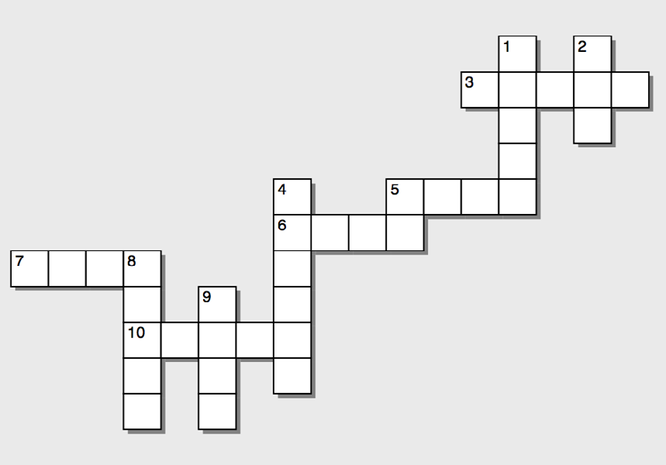

## Across

3) The dress is definitely blue and .

1. This country says it’s developing nuclear power.
2. This country’s army is trying to take back Tikrit.
3. The dress is definitely white and .

10) Apple plans to make these more diverse.

## Down

1. This effect describes rising intelligence.
2. This agency says the Internet is a public utility.
3. Iraq is trying to take back control of this city.
4. This is a measure of human intelligence.
5. This item divided people over its true color.
6. There are more male executives named this than female executives.